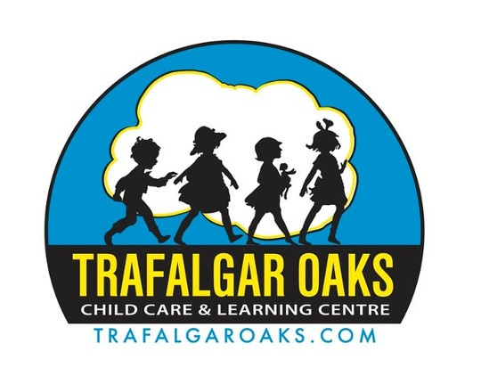

High School Co-op
Information Package

ABOUT US

Trafalgar Oaks Child Care & Learning Centre located in Oakville is a not-for-profit Early Learning Facility operated by a volunteer Board of Directors that offers quality child care and programs to children 15 months—5 years of age. The Centre is licensed by the Ministry of Education in accordance with standards set forth by the Child Care & Early Years Act. Trafalgar Oaks is dedicated to offering a quality program to the community and demonstrates its’ desire to do so through its’ participation in the Quality First program. The Centre is housed in a state-of-the-art facility that was built and designed specifically for child care.
We follow a play-based Emergent Curriculum that fosters the social, physical, cognitive, creative and emotional growth of the child. We strive to enhance each child’s natural curiosity and love of learning. We provide opportunities for each child to master tasks that are appropriate to their individual learning level.
Currently College Students enrolled in the Early Childhood Education Program use our site for their placement to obtain invaluable work experience. High School Students completing their co-op placement or needing to complete volunteer hours, are also welcome. Our site is also used as a facility for conducting workshops, such as the Region led Preschool Inquiry Group,
How Does Learning Happen, hiring of summer students through the Federal Government initiative as well as hiring and teaching students enrolled in College related programs. We provide mentorship to new and existing Centres, meeting with their staff and supervisors, touring them in our facility and networking in order to share our skills and experience.

WORKING AS A CO-OP STUDENT

Benefits of a Co-op Program for Students:

- Pursue a work placement in a field of interest.
- Earn high school credits through work experience.
- Try out different career options.
- Earn valuable work experience for your resume.
- Make connections with employers.
- Learn new practical skills.
- Build your resume for university/college applications.

Completing a successful Co-op Program with Trafalgar Oaks:

- You will receive Workplace Hazardous Materials Information (WHMIS), Health & Safety, and Accessibility for Ontarians with Disabilities Act (AODA) certifications.
- Participate in interview preparedness sessions (mock interviews).
- You will receive a reference letter highlighting your contribution to the Centre.
- Qualify for potential future employment positions as a summer student/supply (Must be 18 years and older).

CHOOSING TO BECOME AN EARLY CHILDHOOD EDUCATOR YOU CAN EXPECT TO:

- Complete the required hours of unpaid placements in a childcare centre or school.
- Obtain a 2-year college diploma in Early Childhood Education.
- Become a Registered Early Childhood Educator (RECE) with the College of ECE's.
- Potentially have the ability to work in a Licensed Child Care and Learning Centre, Early Years Centre, School Board, Private School, Head Start Programs or Child and Family Programs

ADDITONAL CAREER OPPORTUNITIES
Participating in a co-op program at Trafalgar Oaks is ideal for those interested in pursuing post-secondary education in a variety of areas which include, but are not limited to:
- Early Childhood
- Child Life Specialist
- Social Work
- Pediatric Care
- Resource Consultant
- Occupational Therapy
- Speech Language Pathology
- Early Intervention Agencies
- Education
- Child and Youth Work
- Early Literacy Consulting
- Counseling and Therapy
- Or any other fields that involve working with children

CONTACT US

If you are interested in pursuing a co-op placement with us, please visit our website at: www.trafalgaroaks.com
You can also contact our Staffing Coordinator Jessica Silla at: staffingcoordinator@trafalgaroaks.com
For any other questions or inquiries, you can contact our Program Director Sheila Savard at 905-337-1088 ext.6 or supervisor@trafalgaroaks.com

